Nama: Haddy Firdaus

NIM: 1207070050

Kelas: Telekomunikasi

Praktikum 7 PCD

* Contrast Enhancment

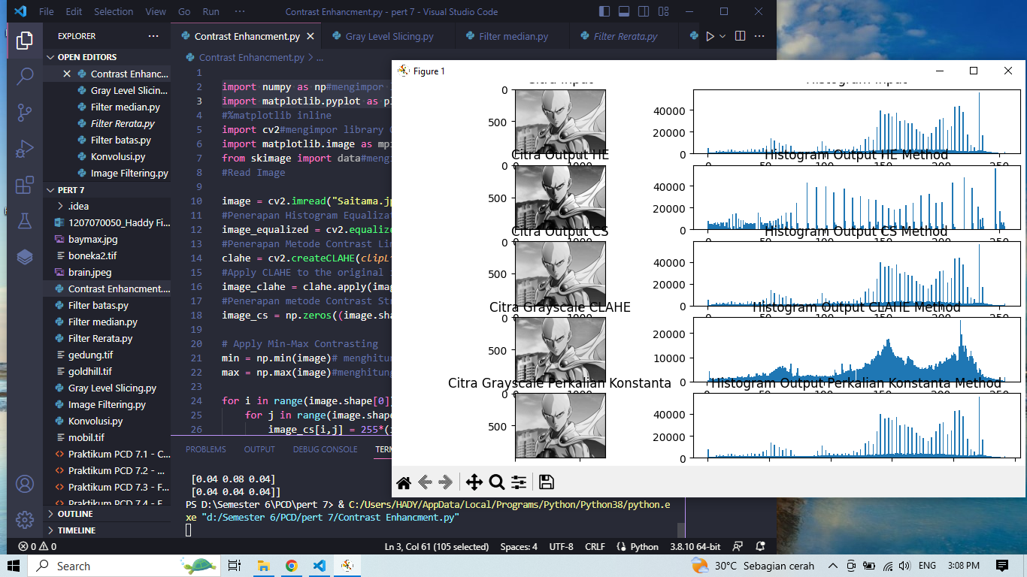

* Gray Level Slicing

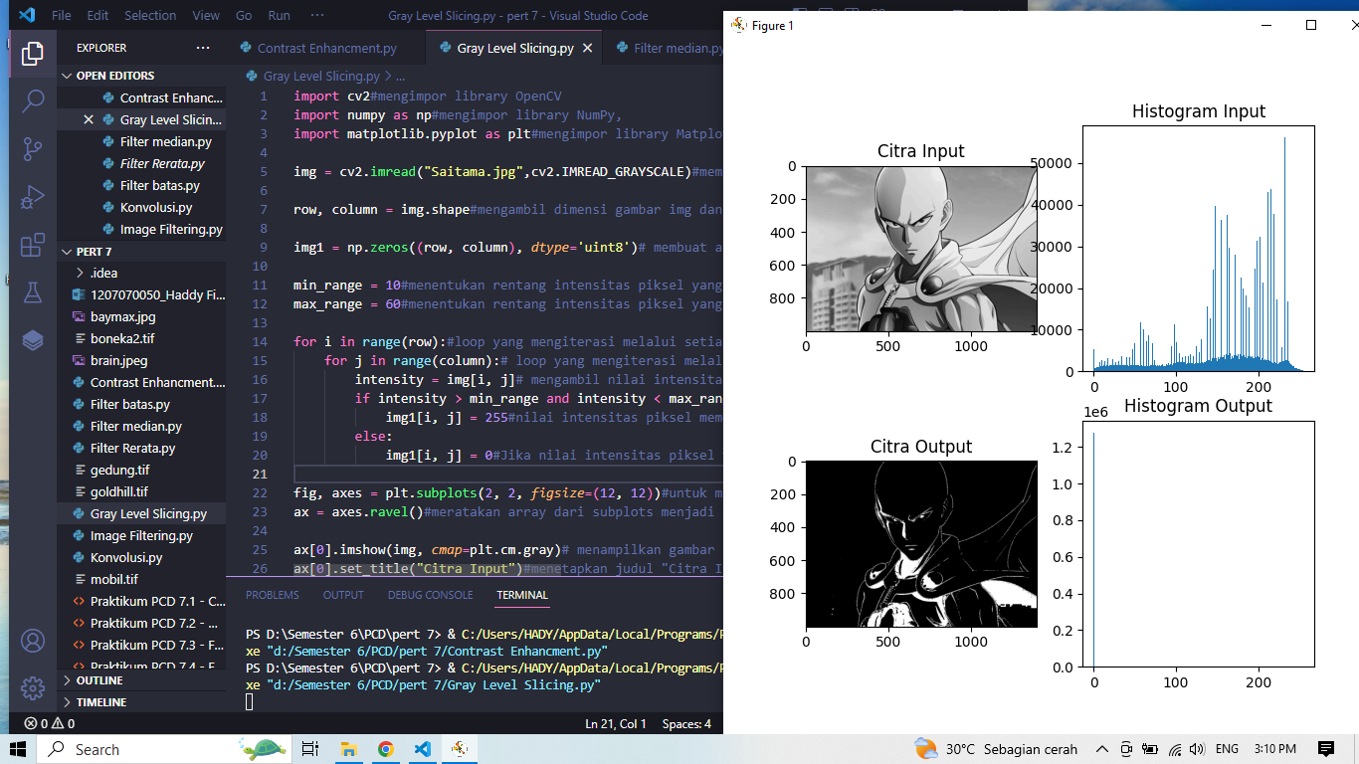

* Filter Rerata

Load & Plot Input Image

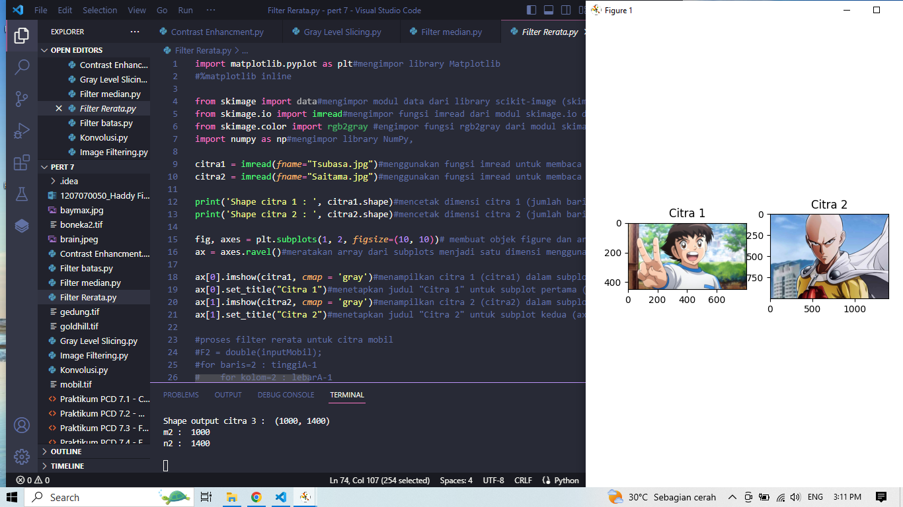

Plot Citra Input dan Output Hasil dari Filter Rerata

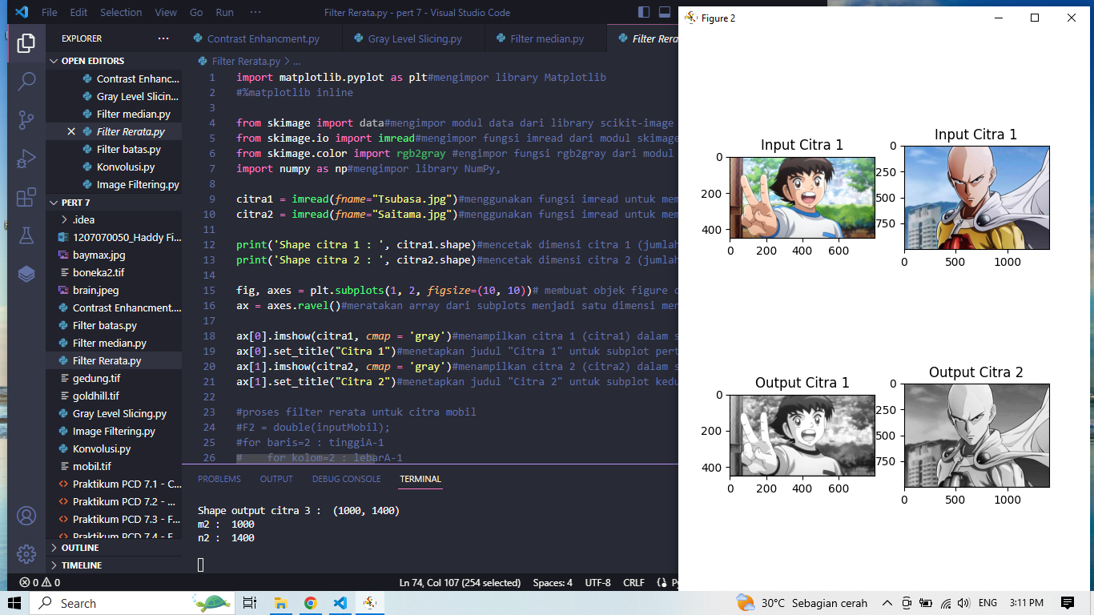

* Filter Median

Load & Plot Input Image

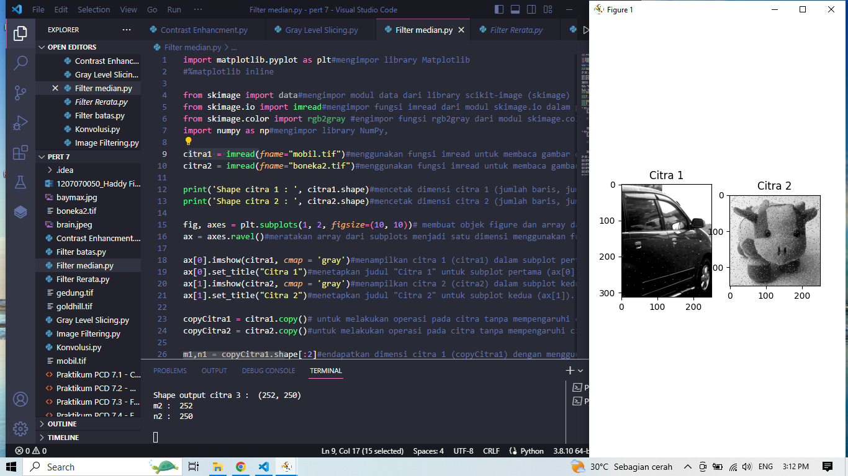

Plot Citra Input dan Output Hasil dari Filter Rerata

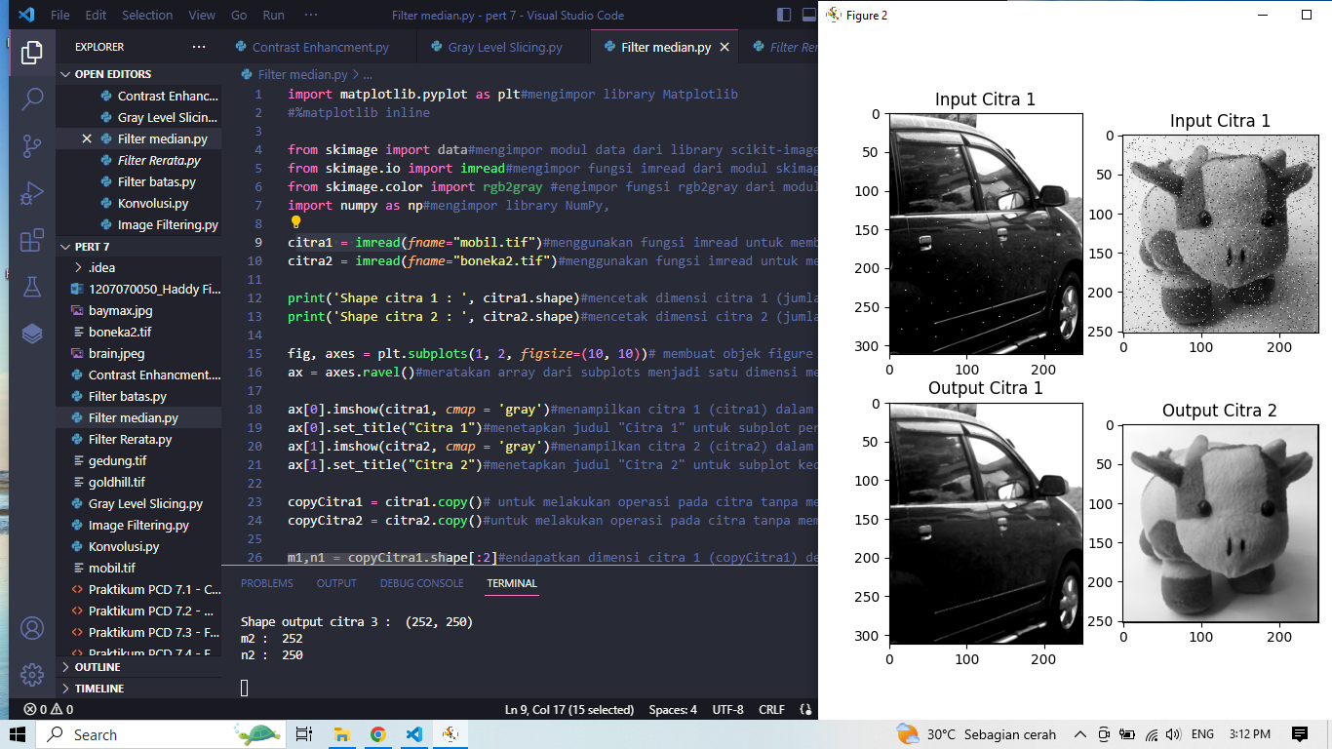

* Filter Batas

Load & Plot Input Image

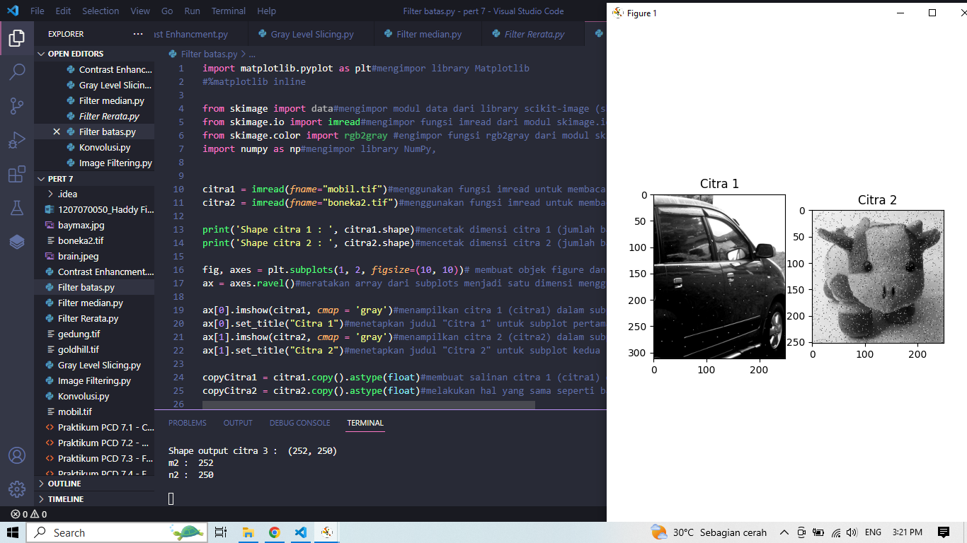

Plot Citra Input dan Output Hasil dari Filter Batas

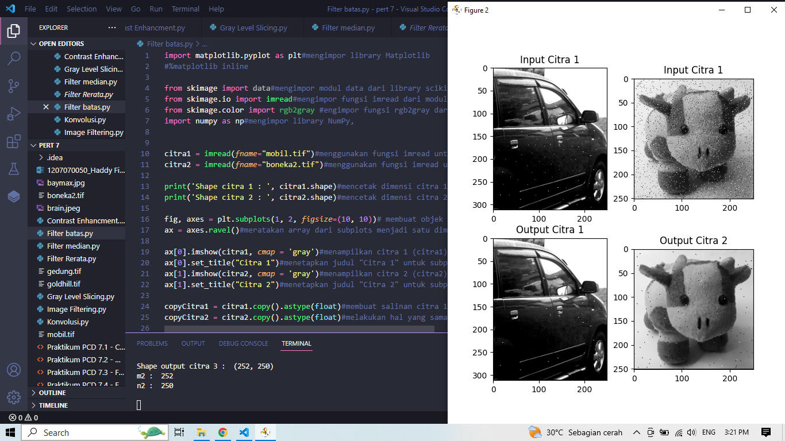

* Konvolusi

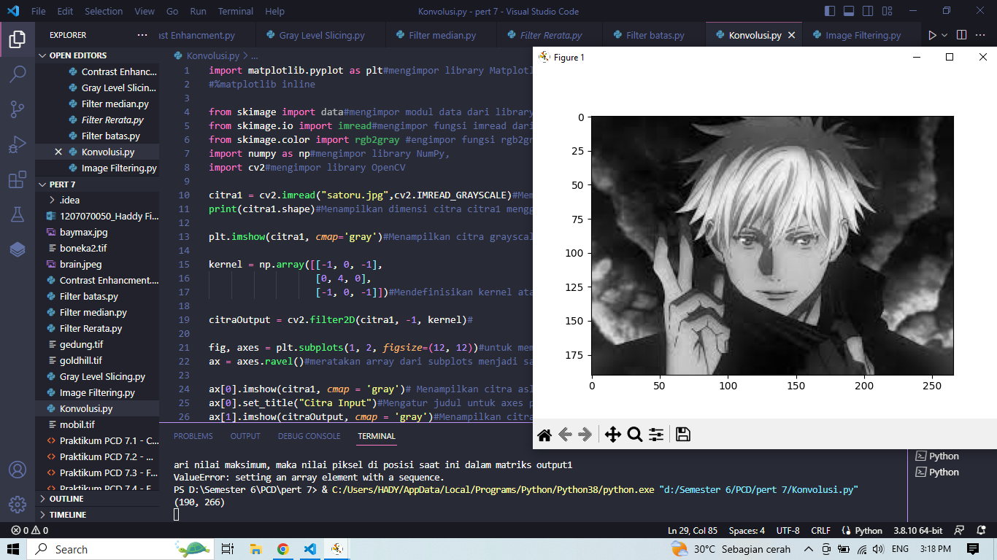

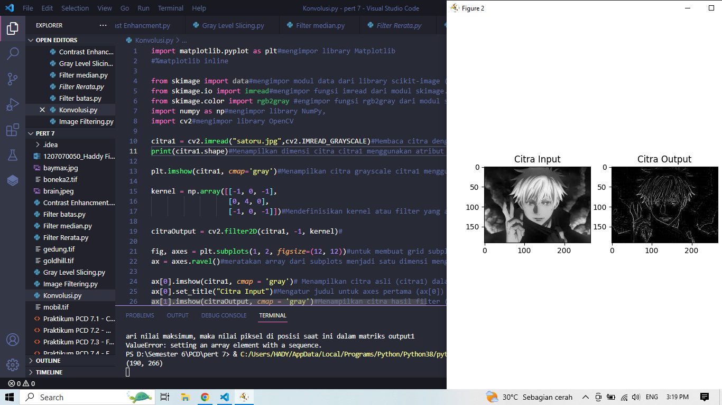

* Image Filtering LPF HPF dan Thresholding

**Low-Pass Filtering**

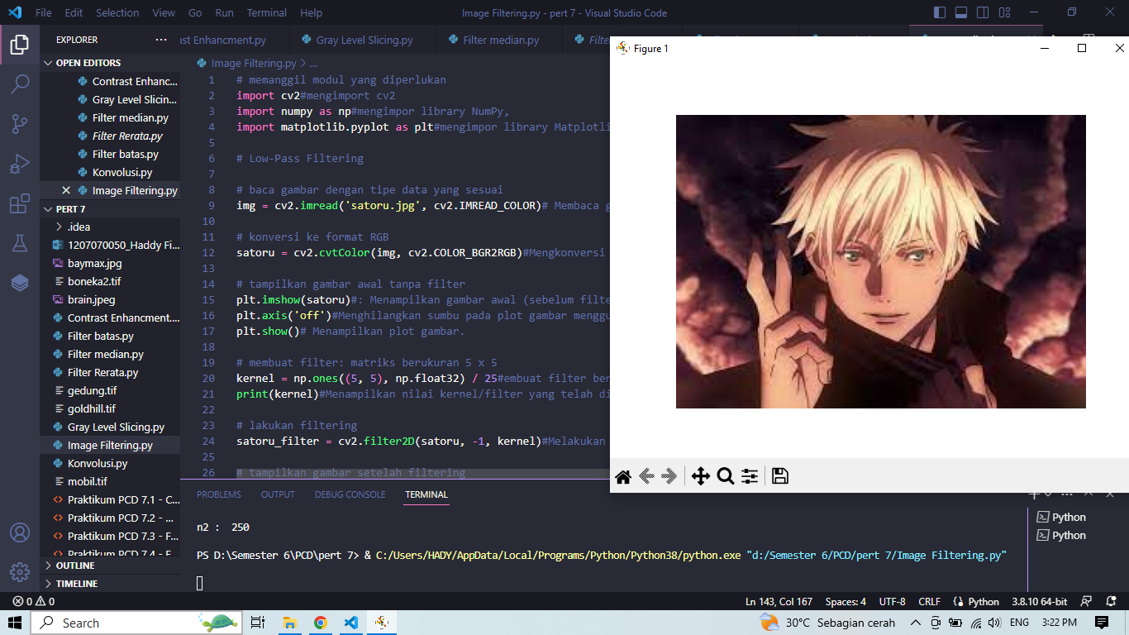

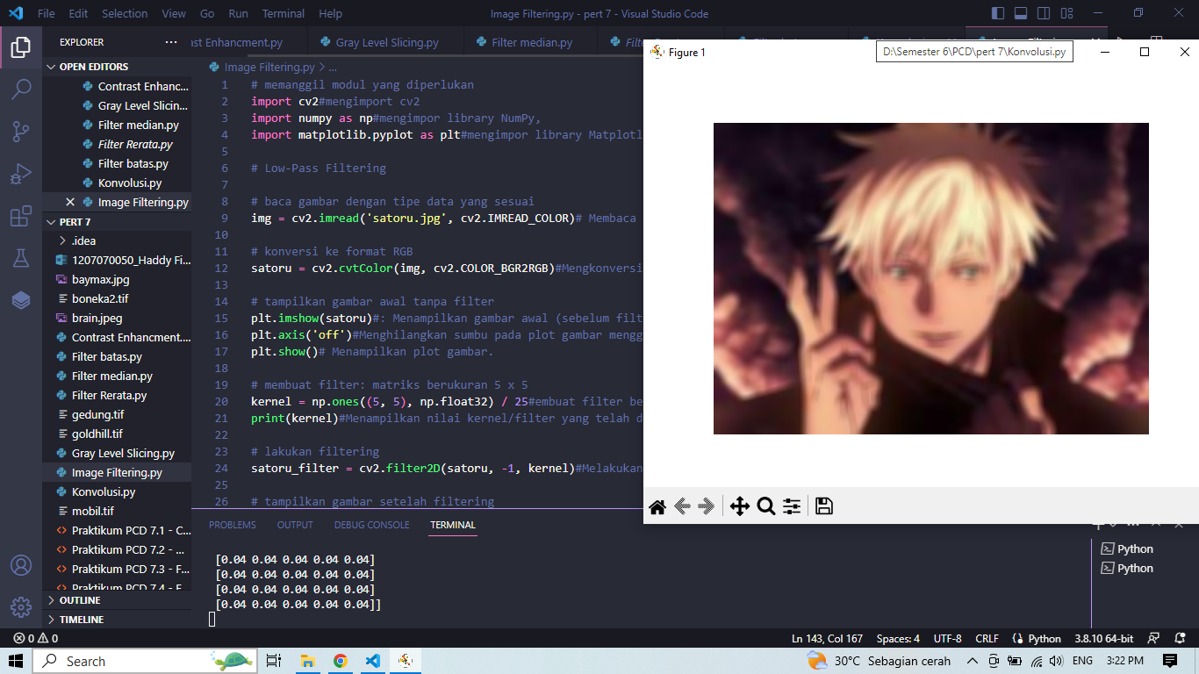

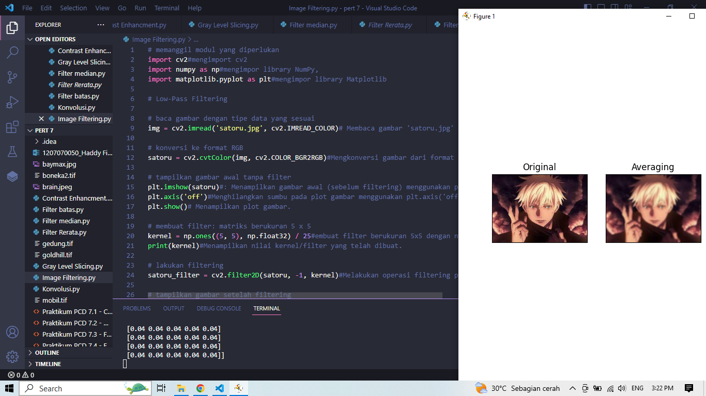

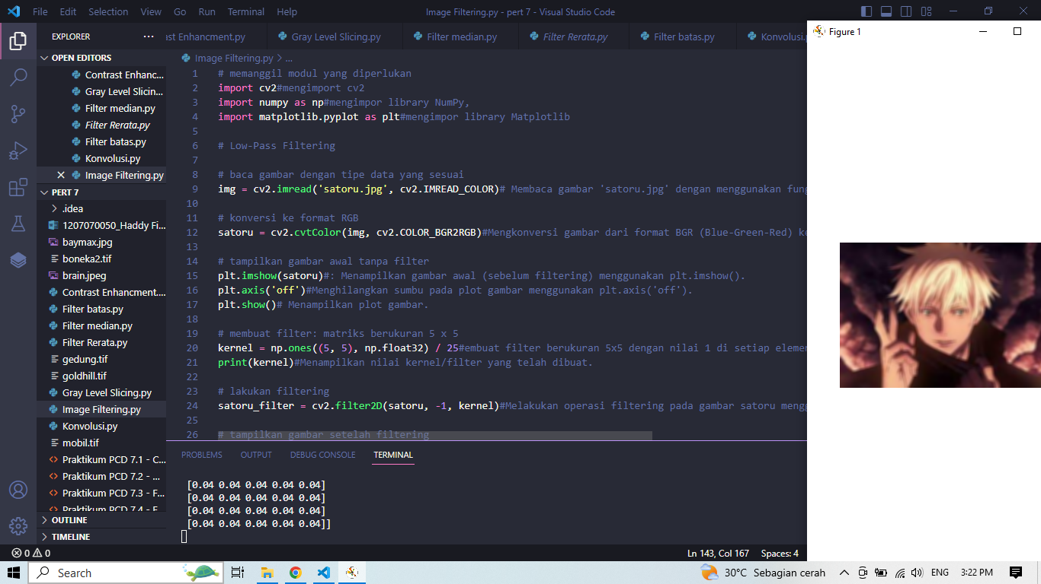

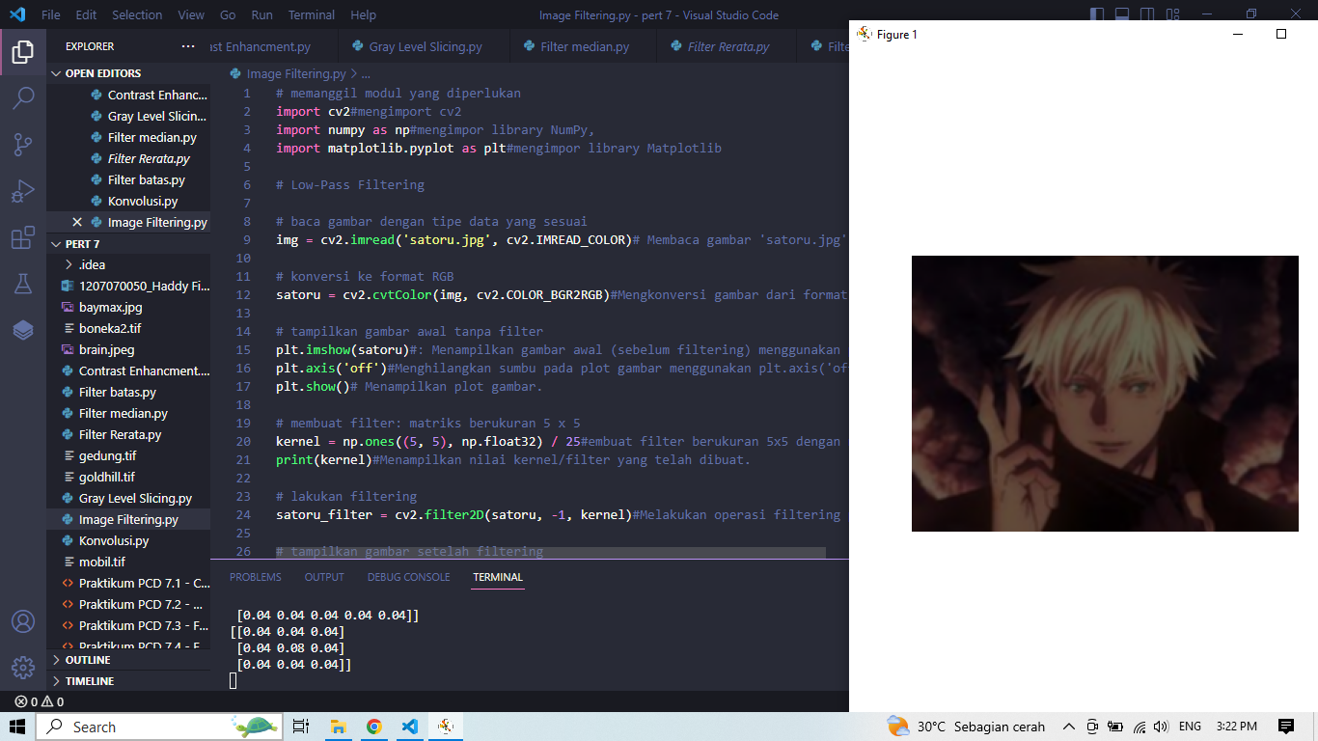

* **High-Pass Filtering**

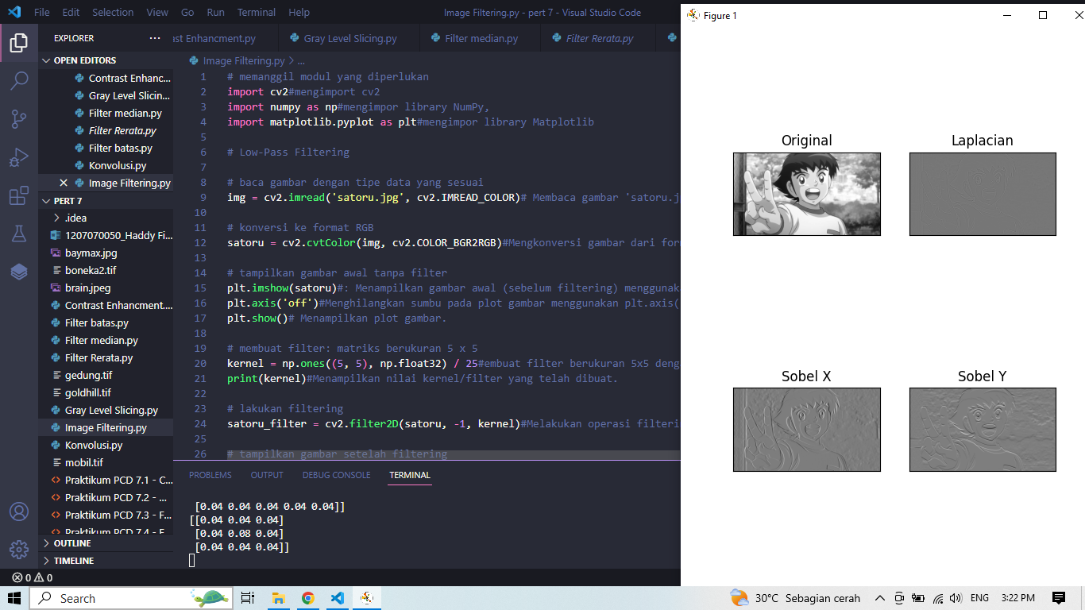

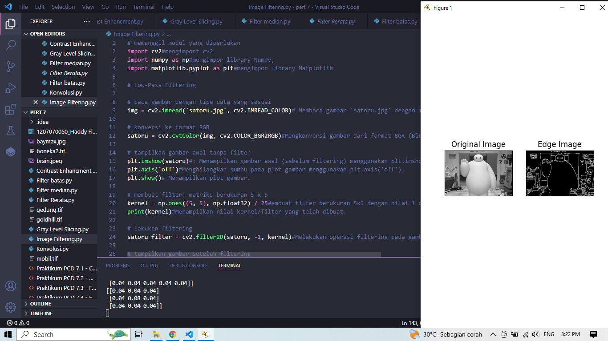

* Image Thresholding

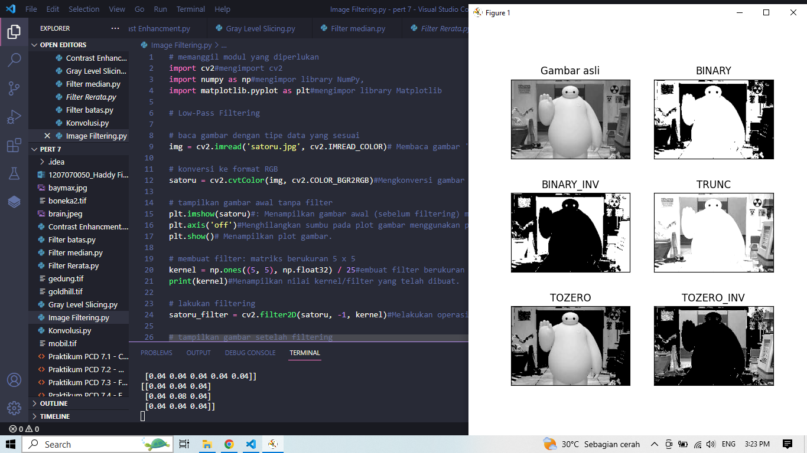

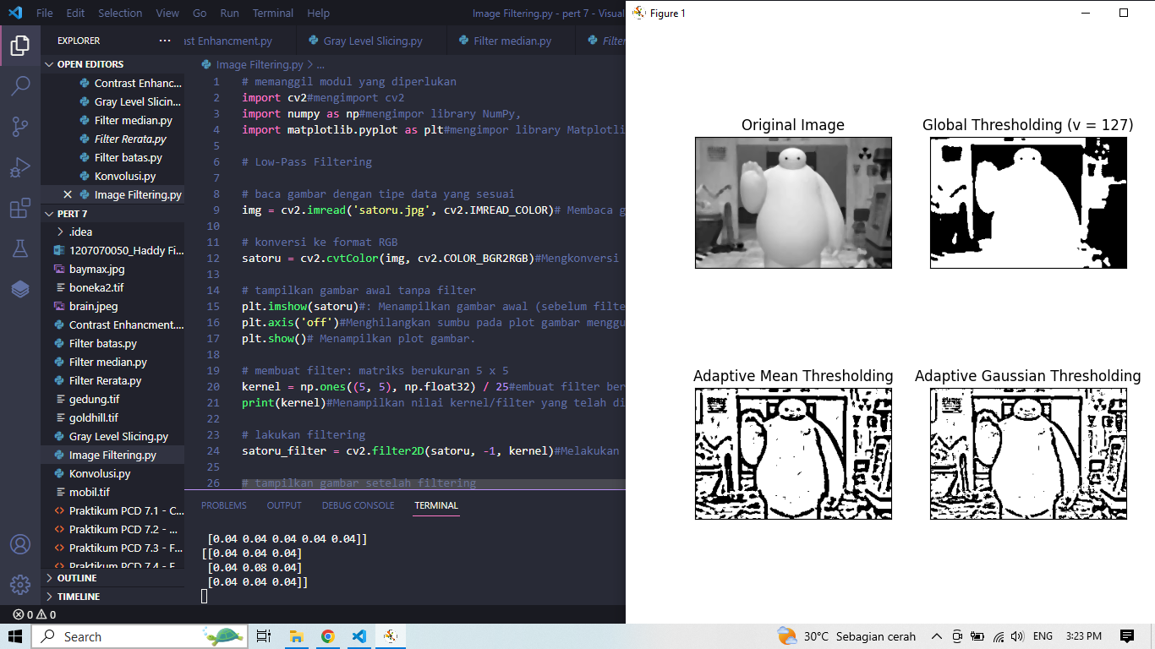

* Link Github

https://github.com/HaddyFirdaus/1207070050-HaddyFirdaus